Project Design Phase-II

Technology Stack (Architecture & Stack)

|  |  |
| --- | --- |
| Date | 15 October 2022 |
| Team ID | PNT2022TMID08799 |
| Project Name | Project - AI-powered Nutrition Analyzer for Fitness Enthusiasts |
| Maximum Marks | 4 Marks |

# Technical Architecture:

The Deliverable shall include the architectural diagram as below and the information as per the table1 & table 2

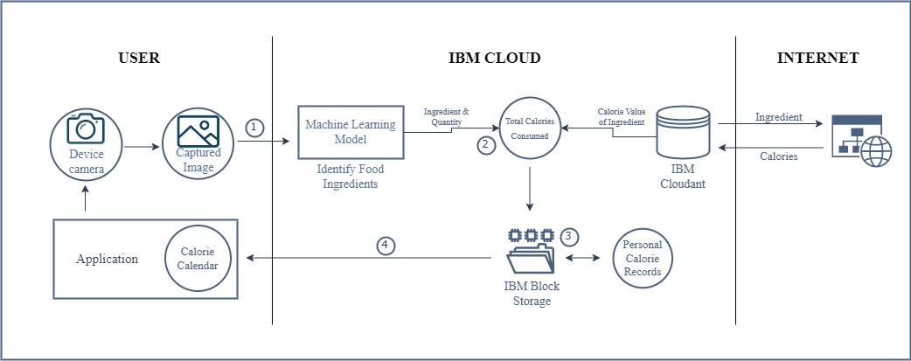

# Table-1 : Components & Technologies:

|  |  |  |  |  |
| --- | --- | --- | --- | --- |
| **S. No.** | **Component** | **Description** | | **Technology** |
| 1. | User Interface | An app that lets users make profiles, upload photos of the components they use in their food, and obtain a personalized nutrition calendar. | | HTML, CSS, JavaScript |
| 2. | Image Capture | Users are required to take a photo of the ingredient(s) they eat. | | IBM Maximo Image Inspection |
| 3. | Ingredient Detection Model | The ingredients used must be identified from the captured image. | Machine Learning & Image Processing using Python | |
| 4. | Calorie Consumption Monitoring | The software monitors the user's daily calorie intake and alerts them when there is an excess. | | IBM Push Notifications |
| 5. | Database of Ingredients | Ingredient information and the relevant calories are kept on file. | | MySQL |
| 6. | Cloud Database for Back-up | Here, backup copies of the application's data are kept, and consolidated reports of monthly calendars are also kept. | | IBM Cloudant |
| 7. | File Storage | A file system is used to keep track of the products consumed each day as well as the daily caloric intake. Additionally, a customized calorie calendar is created using this. | | IBM Block Storage |
| 8. | Calorie Value Consolidation | To determine the calorie counts of components that are saved in the database, a web-scraping API is used. | | Beautiful Soup |
| 9. | Machine Learning Model | To detect substances, captured photos are analyzed using machine learning algorithms. | | Object Recognition Model to Label Ingredients |
| 10. | Infrastructure (Server / Cloud) | The program is deployed to the cloud for use. Configuration of the cloud server: | | Cloud Foundry |

**Table-2: Application Characteristics:**

|  |  |  |  |
| --- | --- | --- | --- |
| **S. No.** | **Characteristics** | **Description** | **Technology** |
| 1. | Open-Source Frameworks | Google Colab, VS Code, Online Websites | Python, HTML, CSS, JavaScript |
| 2. | Security Implementations | Email-based data access authentication and text encryption before file storage | SMTP, Encryption Algorithms |
| 3. | Scalable Architecture | Applications are updated, bugs are fixed, and new features are added in response to user experience and input. | Customer feedback, reviews, and ratings |
| 4. | Availability | Users should always be able to access the cloud-hosted application, and they shouldn't experience any problems like application crashes. | IBM Cloud |
| 5. | Performance | The application should be able to process many requests without sacrificing the speed or quality of the results. | Testing - Black, White, and Beta Revise application in spiral model |